Levrum DataBridge  
User Manual

Version 1.0

# Table of Contents

Table of Contents

Table of Contents 2

Introduction 4

Glossary of Concepts 5

Usage 9

Creating a DataMap 9

Adding Data Sources 10

CSV File Source 10

SQL Server Source 11

Geographical Data Source 12

Creating Data Mappings 13

Setting DataMap Properties 14

Editing Cause Trees 15

Post-Processing Scripts 16

Saving DataMaps 16

Generating Output Files 17

Generating Response Timings 17

Automatically Generated Response Timings 18

Data Mapping Glossary 19

Incident Data Mappings 19

Response Data Mappings 20

Response Timing Mappings 20

This page intentionally left blank

# Introduction

Levrum DataBridge is an application designed specifically to help you get the most out of data contained in your CAD or RMS databases, CSV files, and shapefiles. Using DataBridge you can connect these different sources of information and generate new files containing the merged data in CSV or JSON format.

DataBridge can also be used to correct or re-project the geographical information contained in your data source. You can invert Latitude or Longitude or use an EPSG projection to translate coordinates from State Plane or Web Mercator to Latitudes and Longitudes and back again.

Once you have set up the application to connect to your Data Sources, you can save the resulting configuration as a DataMap file, and these files can be used with Levrum’s other products such as Code3 Strategist, Code3 Firewatch, and Code3 Visionary to streamline your data import process.

DataMap files can also contain post-processing JavaScript functions. These scripts unlock the potential to modify the DataBridge’s output and add or modify information like Cancellation Flags, Hospital Transport Times, and Problem Nature Codes.

Levrum DataBridge comes with built-in templates for connecting to Superion and TriTech Inform CAD systems and for making Code3 Strategist ready files. You can also add your own custom templates or submit them to Levrum Data Technologies for inclusion with future versions of the DataBridge application.

# Glossary of Concepts

**CAD System** – A **Computer Aided Dispatch System** that tracks available and assigned resources. CAD Systems typically store information using a database system such as **Microsoft SQL Server**.

**Category** – An **Incident Data** **Field** containing a description of the generic **Incident** type generated by a **Cause Tree** based on its **Code**. For instance, an Incident with the Code ‘Alpha Medical’ could belong to the ‘EMS’ Category. Categories contain multiple **Types**.

**Cause Tree** – A hierarchical data structure that is used to translate **Code** **Fields** into more abstract **Category** and **Type** Fields.

**Code** – A required **Incident Data Field** containing a description code that identifies the nature of an **Incident** such as an NFIRS code or a short string like ‘Alpha Medical’.

**Coordinate Conversion** – The process of translating **X** and **Y** state plane coordinates into **Longitude** and **Latitude** coordinates.

**CSV File** – A Comma Separated Value (CSV) file ends with the .csv extension and is made up of a header row followed by rows of data with each value separated by a comma. Note: although header rows are optional in CSV files, Levrum DataBridge requires one to function.

**CSV File Source** – A **Data Source** based on a **CSV File**.

**DataMap – A file created with DataBridge containing a set of mappings between Data Sources and Fields that can be used to generate files or retrieve data within Levrum’s other applications.**

**Data Mapping – A relationship between a Data Source and a Field representing Incident Data, Response Data, or a Response Timing.**

**Data Source – A set of data that can be used with Data Mappings to create a DataMap. There are several types of Data Sources, such as CSV Source, SQL Source, and Geographical Source**. CSV Sources and SQL Sources must specify a **Field** that contains the **Incident ID** and **Response ID**.

**Field** – A specific column in a **CSV Source**, **SQL Source**, or **Geographical Source** that can be used to generate **Incident Data**, **Response Data**, or **Response Timings** using a **Data Mapping**.

**Geographical Data Source – An ESRI SHP File or GeoJSON File that contains information about a particular area such as zone or first due station. Using a Data Mapping, information from the Geographical Source can be added as Incident Data and Response Data if the Incident Latitude and Longitude falls within the area described by the file.**

**GeoJSON File – A file type containing geographical information as defined by** <https://geojson.org/>. These files can be exported from tools like QGIS and ESRI ArcGIS and end with the extension “.geojson”.

**Incident** – A unique event that occurs at a certain place in time at a specific location. This could be a Fire/EMS incident, an inspection or service request, or any other type of event. Each Incident can have multiple associated **Responses** based on the **Incident ID**. Incidents are described by **Incident Data Fields** such as **Time**, **Latitude**, **Longitude**, **Location** and **Code**.

**Incident Data** – A piece of data contained in a **Field** that is associated with **Incidents** by a **Data Mapping** or **Post-Processing Script**.

**Incident ID** – A unique identifier associated with an **Incident**. Each **Incident** must have an Incident ID. The **Field** containing Incident IDs is defined in the **Data Source** editor.

**Latitude** – A required **Incident Data Field** for most applications containing a Y coordinate. If necessary, this can be translated from a state plane coordinate contained in the **Y Data Field** using a **Projection**.

**Location** – A required **Incident Data Field** for most applications containing uniquely identify information about the name of the location of an **Incident** such as an address or an ER bed.

**Longitude** – A required **Incident Data Field** for most applications containing an X coordinate. If necessary, this can be translated from a state plane coordinate contained in the **X Data Field** using a **Projection**.

**Microsoft SQL Server** – A SQL database system released by Microsoft and used by several major **CAD System** vendors such as **Superion** and **TriTech Inform**. See <https://www.microsoft.com/en-us/sql-server/default.aspx> for more information on Microsoft SQL Server.

**Post-Processing Script** – A piece of JavaScript that is run at the end of processing a **DataMap** which can be used to create and modify **Incidents, Responses, Incident Data, Response Data,** and **Response Timings**.

**Projection** – A set of information in a format known as WKT that can be associated with a **Geographical Source** or used to translate coordinates from state plane X and Y coordinates to **Latitudes** and **Longitudes**. See <https://spatialreference.org/ref/epsg/> for a list of projections.

**Response** – A unique event that occurs due to an **Incident**. Responses are identified by a combination of unique **Response ID** and **Incident ID**. Multiple Responses may have the same Response ID as long as they have unique Incident IDs. Responses are described by **Response Data Fields** and **Response Timings**.

**Response Data** – A piece of data such as a unit type contained in a **Field** that is associated with a **Response** by a **Data Mapping** or generated by a **Post-Processing Script**. Generic Response Data differs from **Response Timings** primarily based on the type of data described. Response Timings should be used whenever the Field in question describes a specific date and time or an amount of time spent.

**Response ID** – A unique identifier associated with a **Response**. This may be reused by multiple Responses as long as each Response is for a different **Incident**. For example, each Response for an **Incident** could be identified by the name of the unit or person who responded. The same unit may respond to multiple Incidents, and each time a unique Response will be generated.

**Response Timing** – A specific type of **Response Data** containing a date and time or a number of elapsed minutes such as an assigned time or a responding time. Response Timings are described by a **Field** that is associated with a **Response** by a **Data Mapping** or are generated by a **Post-Processing Script**.

**SHP File** – A file type containing geographical information based on ESRI’s specification located at <https://www.esri.com/library/whitepapers/pdfs/shapefile.pdf>. These files can be exported from tools like ESRI ArcGIS and QGIS and end with the extension “.shp” or “.zip”. SHP files are typically accompanied by many other files. The most important for the DataBridge is the .PRJ file.

**SQL Query** – A statement written in Structured Query Language that retrieves information from a database contained on a system like a **Microsoft SQL Server**. A SQL Query can be specified by a **SQL Source** to generate rows and columns based on multiple **SQL Tables**.

**SQL Server Source** – A **Data Source** based on a connection to a **Microsoft SQL Server**. This database can contain information from a **CAD** or **RMS** or any other type of data. SQL Sources can point to a **SQL Table** or a **SQL Query**.

**SQL Table** – A table contained in a database on a system like a **Microsoft SQL Server**. SQL Tables are made up of rows and columns and can be used as part of a **SQL Source**.

**Superion** – Superion is a **CAD** **System** developed and distributed by CentralSquare, a public sector technology vendor.

**Time** – A required **Incident Data** **Field** describing when the first event associated with an **Incident** occurs. This field is used when generating dates for **Response Timings** if the Response Timing contains elapsed minutes instead of a date and time.

**TriTech Inform** – Tritech Inform is a **CAD** **System** developed and distributed by CentralSquare, a public sector technology vendor.

**Type** – An **Incident Data** **Field** containing a description of the generic **Incident** type generated by a **Cause Tree** based on its **Code**. For instance, an Incident with the Code ‘Alpha Medical’ could belong to the ‘Medical’ Category. **Types** generally contain multiple Codes.

**Unit** – A required **Response Data Field** containing the unit identifier for a unit that is involved in a **Response** to an **Incident**.

**X** – An **Incident Data Field** containing a state plane coordinate on the horizontal axis. When **Coordinate Conversion** is enabled, this field can be used in conjunction with a **Projection** to generate the **Longitude** field.

**Y** – An **Incident Data Field** containing a state plane coordinate on the vertical axis. When **Coordinate Conversion** is enabled, this field can be used in conjunction with a **Projection** to generate the **Latitude** field.

# Usage

The DataBridge application contains two separate groups of functionalities. The first is **Creating a DataMap** and consists of specifying **Data Sources**, creating **Data Mappings**, and **Setting** **DataMap Properties**. The second is **Generating Output Files** which uses the information from a DataMap to produce output for use in other applications such as Levrum’s Code3 Strategist.

# **Creating a DataMap**

The process of creating a DataMap is best understood by breaking it down into a series of distinct steps. These steps are Creating a DataMap, Adding Data Sources, Creating Data Mappings, Setting DataMap Properties, and Writing Post-Processing Scripts.

To begin creating a New DataMap, select the New option from the File menu or click the New DataMap icon on the toolbar. This will open the Create New DataMap window, which offers you a selection of various DataMap templates to start with.

The Code3 Strategist template contains predefined field mappings that Code3 Strategist requires to function.

The Superion and TriTech Inform templates contain predefined SQL Queries designed to streamline interfacing with a CAD System using a Microsoft SQL Server. When selecting these templates, you will be prompted to enter your database address and credentials.

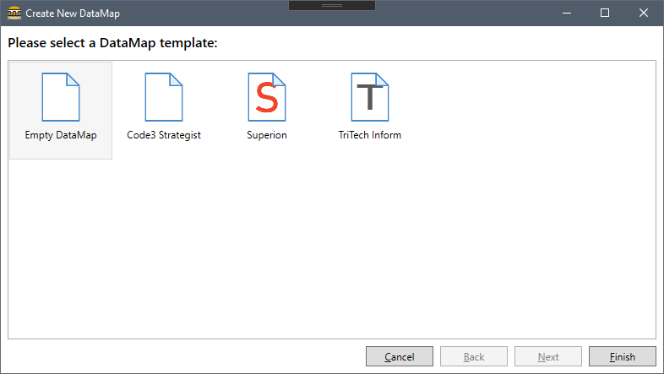

## Adding Data Sources

After creating a new DataMap you will need to add one or more Data Sources. This is done from the Data Sources pane located by default at the bottom of the DataBridge window.

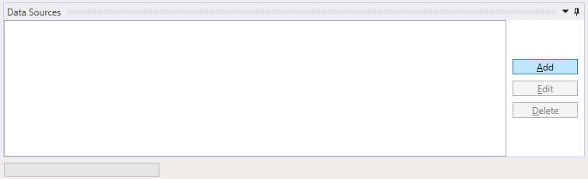

Clicking the Add or Edit buttons will open up the Data Source Editor. Within the Data Source Editor, you may select the Data Source Type, enter a Data Source Name, and enter details specific to the type of Data Source. The DataBridge supports multiple Data Source Types. These are CSV File Source, SQL Server Source, and Geographical Data Source.

### CSV File Source

CSV File Sources allow you to retrieve information from files saved in the CSV format and use it as part of your DataMaps. If you do not provide a name for the CSV Source one will be automatically generated. To choose the CSV file you wish to use, click the Select… button and find the file on your computer.

Once you have selected a CSV File, you must select an Incident ID column before you can save the Data Source. The Incident ID column is used by DataBridge to identify pieces of information with a particular incident record. When joining multiple data sources, incident records must have the same Incident ID value in order to be linked.

If the CSV Source contains information you wish to use in a Response Data or Response Timing field, you must select a Response ID column. Just like with the Incident ID, if you wish to join multiple data sources to create response records, all data sources must contain the same Incident ID and Response ID. Note that the columns do not need to have the same names, but they must contain the same data.

After selecting a CSV file, clicking the Summarize button will display an overview of the file’s contents in the Summary pane. This overview allows you to see which columns are available in the CSV file, what type of data they contain, and some statistics depending on the data type.  
  
You can also choose to embed the CSV file in your DataMap. This is useful when you want to send a DataMap to someone else, but it will increase the size of the DataMap. Note that embedding large CSV files will take a significant amount of time, because the embedded CSV files have to be converted to a format that can be stored with the DataMap.

Once you have configured the Incident ID and Response ID columns, click Save to add the CSV Source to your DataMap and return to the main window.

### SQL Server Source

SQL Server Sources allow you to retrieve information from Microsoft SQL Server databases and use it in your DataMaps. You can either get information from tables directly or write a custom SQL Query to join several tables together at once. The TriTech Inform and Superion DataMap templates are both based on SQL Server data sources.

Before you can select a table or choose the Incident ID Column or Response ID Column, you must first type in the connection details for the SQL Server you wish to use. In the Server box, type the SQL Server’s IP Address or domain name. For most Microsoft SQL Server instances the port is ‘1433’. You will need to obtain a User Name and Password from your SQL Server Administrator in order to complete the connection. Finally, the Database field should contain the name of the database which contains the tables you wish to use.  
  
Once you have entered in these details, click the Connect button to verify they are correct. This will also populate the Table, Incident ID, and Response ID dropdown boxes. If using a Query, clicking the Connect button will attempt to run the query and retrieve the columns it returns. Like with the CSV Data Source type, you must select an Incident ID Column before you can save the Data Source.  
  
Because the Data Source Editor offers only very limited functionality for testing SQL queries, we recommend you develop your SQL query in an external tool such as SQL Server Management Studio and then cut and paste the query into the editor once it runs the way you expect. You can download SQL Server Management Studio at the following link: <https://bit.ly/MSSQLSMS>

### Geographical Data Source

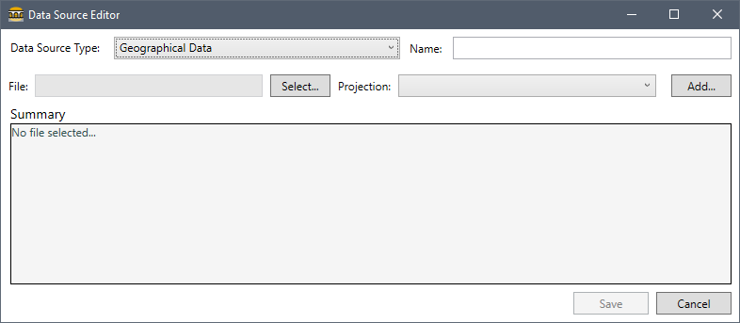

Geographical Data Sources allow you to add information to Incidents and Responses based on where they occur. In order to use information from a Geographical Data Source, your Incident Data fields must contain Latitude and Longitude mappings. DataBridge will use those mappings to determine if the incident falls within the shape described by the Geographical Data Source. DataBridge accepts GeoJSON and ESRI Shapefiles as Geographical Data Sources. In most cases you will not need to modify or select a Projection. After loading a data source, the Summary box will be automatically populated with information about the shapes the file contains and their properties. These properties can be used in data mappings.

## Creating Data Mappings

Once you have added the Data Sources you wish to use for your DataMap, the next step is to create **Data Mappings**. There are three types of data mappings available that you can create. The first are called **Incident Data** mappings, the second are **Response Data** mappings, and the third are **Response Timings** mappings. Incident Data mappings represent data that is associated with a specific incident, Response Data mappings represent textual data associated with a specific response, and Response Timing mappings represent the time at which a specific event occurred as part of a Response. Data used in Response Timings mappings should either be in a DateTime format or a number representing the total number of minutes that had elapsed since the Incident Time or FirstAction Time.

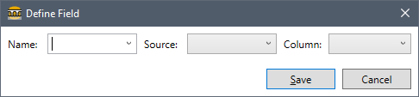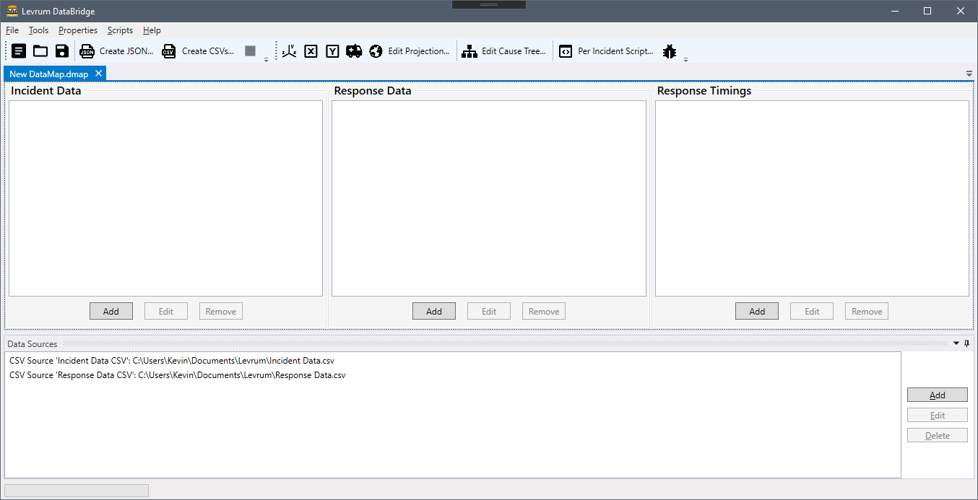To add a Data Mapping, click the Add button underneath the section for the appropriate mapping type. This will open the Define Field window.

The three controls in the Define Field window represent the three parts of the column mapping. The first control, “Name”, is where you define what the data will be named in the output. DataBridge comes with several field names predefined.

Most of these have specific functionality associated with them or are required fields for Levrum’s other products such as Code3 Strategist or Code3 Visionary. Clicking on the arrow to the right of the Name will open a dropdown menu that allows you to pick from these presets. You may also type in a custom name if you have custom pieces of data or need to use your own name for the field. For a complete list of predefined names and their associated functionality, please refer to the Data Mapping Glossary.

The second control, “Source”, is where you select which Data Source the column mapping should use in order to retrieve the data.

Once you select a Data Source the third control, “Column”, will be populated with a list of columns from the Data Source you selected. After you have defined all three pieces of information for the Data Mapping, click Save. Note that while you can save an incomplete mapping, DataMaps with incomplete or incorrect data mappings will not run properly.

Once you have created a column mapping it can be edited or removed using the appropriate buttons underneath the Data Mapping groups.

## Setting DataMap Properties

DataMaps have several properties other than Data Mappings and Data Sources that are used to determine how the output is generated. These properties are available from the toolbar and in the Properties Menu.

The Properties Toolbar, shown to the right, is made up of several buttons that allow you to toggle or edit properties. From left to right, these buttons are “Toggle Coordinate Conversion”, “Toggle Invert Longitude”, “Toggle Invert Latitude”, “Toggle Transport as ClearScene”, “Edit Projection…”, and “Edit Cause Tree…”

Inverting Longitudes and Latitudes may be necessary in some cases where a CAD system stores negative Latitudes or Longitudes using positive numbers, for instance TriTech Inform stores its west Longitudes as positive numbers even though they are negative Longitudes.

Toggle Coordinate Conversion and Edit Projection… are used in conjunction with each other to translate state plane coordinate data contained in the X and Y fields into Longitudes and Latitudes. Clicking Edit Projection… will open a window where you can enter the projection used to define your state plane coordinates. This projection should be in the Well-Known Text Format (WKT).

Toggle Transport as ClearScene allows you to specify that a Response Timing mapping named “Transport” should be used when available to define the Response Timing “ClearScene”. This is useful in applications where you wish to specify that an ambulance en route to the hospital or a police cruiser en route to a jail is considered to have cleared the scene of an incident.

### Editing Cause Trees

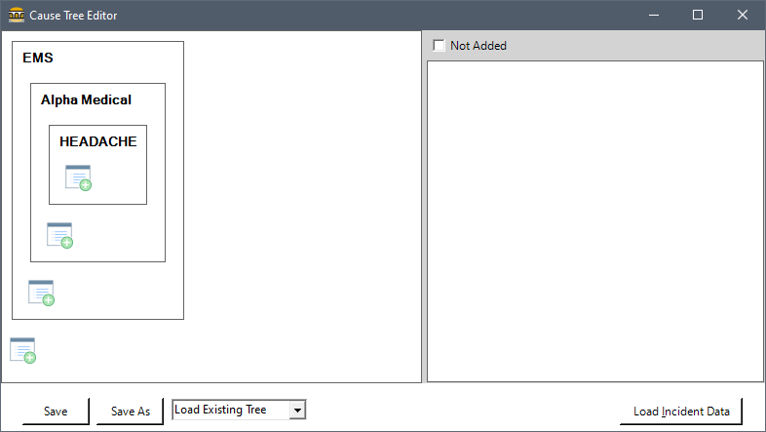  
Edit Cause Tree… is used to define what is known as a Cause Tree which is used to translate nature codes associated with an incident into broader categories for grouping. This is used specifically by Code3 Firewatch but is also useful for custom applications. Clicking Edit Cause Tree… will open the Cause Tree Editor window.

The Cause Tree operates by reading the contents of an Incident Data mapping named “Code” and translating it into two others named “Category” and “Type”. Category is the broadest grouping and Type is the second broadest. In the graphic shown above, the category for the HEADACHE nature code is EMS and the Type is Alpha Medical.

Cause Trees can be saved for later use or exported from Code3 Strategist models and loaded by clicking the Load Existing Tree control and choosing Browse…

Nature codes may be loaded from existing Incident Data and then used to build a Cause Tree by clicking the Load Incident Data button and selecting a file containing Incident Data JSON. Such a file can be generated with a simple DataMap containing only a Code mapping for use building your cause tree.

## Writing Post-Processing Scripts

DataBridge allows users to create their own post-processing scripts using JavaScript to modify the imported data after the DataMap has been run but before the files it creates are saved. This is useful in circumstances where your data contains errors or the contents of a field must be translated from a format used in your database to a different format expected by an application. You can add or alter Incident Data, Response Data, or Response Timings, or create new Incident and Response records from scratch.

There are three post-processing scripts available. They are the Post-Loading Script, which is executed after data has been loaded from your Data Sources but before any processing has taken place, the Per-Incident and Final Processing Scripts which are executed at the very end of the DataMap loading process. The Per-Incident script is run once per incident that is generated by the DataMap and is passed an object named Incident that allows you to refer to each Incident individually without having to iterate through the DataSet in JavaScript.

For example, you could write a Post-Loading Script that cleans up the data in the Code field prior to the Cause Tree being used to generate the Category and Type fields. You could then run a Per-Incident script that modifies a Response Timing or adds other data. Once that is complete, you could write a Final Processing script that calculates statistics based on your modified Response Timing and adds that information as a piece of Incident Data.

For more information on Post-Processing scripts please see the Post Processing guide, available from the Help menu as a separate document.

## Saving DataMaps

Once you’ve finished creating your DataMap you can save it from the File menu or by clicking the Save Icon located on the toolbar. DataMaps are saved with a special “.dmap” extension that allows you to easily open them in DataBridge and use them with Levrum’s other applications.

# **Generating Output Files**

Once you’ve created your DataMap you can use it to generate output directly from DataBridge. DataBridge provides two options for generating output files, “Create JSON…” and “Create CSVs…” which are both available from the File menu and from the toolbar.

The Create JSON… option generates a single Incident Data JSON file. Incident Data JSON is primarily used by Code3 Visionary, Code3 Alarm, and Code3 Firewatch, and can also be imported into Code3 Strategist as a result set.

The Create CSVs… option generates an Incidents CSV file and a Responses CSV file containing Incident Data and Response Data with Response Timings respectively. These CSV files can be used with the Code3 Strategist importer to generate new Real-World Data and call files. These CSVs can also be opened with Excel and used to generate reports or charts and can be used in any other external application that supports the CSV format.

Clicking on one of the buttons will prompt you to specify where you want to save the files, and then begins the Map Loading process. This is a multi-step process which may take a significant amount of time depending on how much data you are processing, whether or not you use a large number of Geographical Data shapes, and the types of Post-Processing Scripts you are using.

For a simple DataMap with 100k records from a CSV Source, load times are usually between 30 seconds and a minute. For a more complicated DataMap with 500k records and a complex Per-Incident Post-Processing Script, load times could be between 20 and 30 minutes due to the script run time.

During the load process the Status Bar at the bottom of the application will update with messages informing you about the loading progress. If you wish to abort the load process you may do so by pressing the Stop button located on the toolbar next to the Create JSON… and Create CSVs… buttons, and no files will be created.

Once the load process is complete you will receive a message in a popup dialog informing you the files have been saved.

## Generating Response Timings

During the load process one of the steps the Map Loader executes is called the Process Response Timings step. This step attempts to determine whether the defined Response Timings Fields are using numerical or DateTime data, and it also automatically generates additional Response Timing data based on which fields are present.   
  
  
If the Response Timings you define are using numerical minutes since the Incident occurred, DataBridge will automatically create DateTime values for the fields. These values are based on the Time Incident Data Field, unless the FirstAction Incident Data Field is defined, in which case its value is used instead.

### Automatically Generated Response Timings

As part of the Process Response Timings step the following Response Timings based on derived information are automatically generated and included with your Response Data. If these Response Timing fields are defined in your DataMap then the derived values will not be used.

**TurnoutTime** – This Response Timing is defined by the difference between the Assigned timing data and the Responding timing data and represents how long it took the unit to respond after being assigned. It is stored as a number of fractional minutes.

**TravelTime** – This Response Timing is defined by the difference between the Responding timing data and the OnScene timing data and represents how long it took the unit to arrive at the Incident after being assigned. It is stored as a number of fractional minutes.

**CommittedHours** – This Response Timing is defined by the difference between the Assigned timing data and the ClearScene timing data and represents how long the unit was committed to the Incident. It is stored as a number of fractional minutes.

**SceneTime** – This Response Timing is defined by the difference between the OnScene timing data and the ClearScene timing data and represents how long the unit actually spent on scene at the incident. It is stored as a number of fractional minutes.

# Data Mapping Glossary

The Data Mapping Glossary describes the pre-defined Fields built into DataBridge and how they interact during the loading process in order to create Incident Data and Response Data. Users are not limited to the pre-defined Fields but many of them contain special functionality or are required.

## Incident Data Mappings

**Time (Required)** – An Incident Data Mapping field containing the Time at which the Incident is considered to have occurred. In Fire/EMS applications this is typically the Call Received time. This field must contain data in a valid DateTime format such as “2020-05-14 09:21:38”. This is a required field for most Levrum applications.

**Latitude (Required)** – An Incident Data Mapping field containing the Latitude at which the Incident occurred. If using the Coordinate Conversion feature this field is used to hold the Y coordinate prior to the conversion being executed. This is a required field for most Levrum applications.

**Longitude (Required)** – An Incident Data Mapping field containing the Longitude at which the Incident occurred. If using the Coordinate Conversion feature this field is used to hold the X coordinate prior to the conversion being executed. This is a required field for most Levrum applications.

**Location (Required)** – An Incident Data Mapping field containing the Location at which the Incident occurred. In Fire/EMS applications this is typically the Address of the location. This is a required field for most Levrum applications.

**City** – An Incident Data Mapping field containing the City in which the Incident occurred. This is an optional field for most Levrum applications.

**State** – An Incident Data Mapping field containing the State in which the Incident occurred. This is an optional field for most Levrum applications.

**Code (Required)** – An Incident Data Mapping field containing the nature code associated with a specific Incident. This is a required field for most Levrum applications and is used by the Cause Tree functionality to generate Category and Type fields.

**Category** – An Incident Data Mapping field containing the topmost grouping associated with a specific nature code contained in the Code field. This field can be auto-generated using the Cause Tree functionality and is required by Code3 Firewatch.

**Type** – An Incident Data Mapping field containing the second level grouping associated with a specific nature code contained in the Code field. This field can be auto-generated using the Cause Tree functionality and is required by Code3 Firewatch.

**Jurisdiction** – An Incident Data Mapping field containing the Jurisdiction in which an Incident occurred. This is an optional field for most Levrum applications that may enable additional functionality when present.

**District** – An Incident Data Mapping field containing the District in which an Incident occurred. This is an optional field for most Levrum applications that may enable additional functionality when present.

**CallProcessed** – An Incident Data Mapping field containing the time that the dispatcher finished processing the call for an Incident and started dispatching Units for a Response. This is an optional field for most Levrum applications that may enable additional functionality when present.

**Cancelled** – An Incident Data Mapping field containing either “Y” or ”N” indicating whether or not the Incident was cancelled at any point in time after the call was received. This is an optional field for most Levrum applications that may enable additional functionality when present.

**FirstAction** – An Incident Data Mapping field containing the time at which the first effective action in response to the incident occurred. If this field is present its value is used as the base time for calculating Response Timings in place of the Time field. This field must contain data in a valid DateTime format such as “2020-05-14 09:21:38”. This is an optional field for most Levrum applications that may enable additional functionality when present.

Response Data Mappings  
  
**Unit (Required)** – A Response Data Mapping field containing the Name of the Unit making the Response. This is a required field for most Levrum applications.

**Unit Type** – A Response Data Mapping field containing the Type of the Unit making the Response. This is an optional field for most Levrum applications that may enable additional functionality when present.

**Urgency** – A Response Data Mapping field containing the Urgency of the Response, such as Code 1 or Code 3 or an NFIRS Urgency. This is an optional field for most Levrum applications that may enable additional functionality when present.

**Shift** – A Response Data Mapping field containing the Shift that the was working when the Response was made. This is an optional field for most Levrum applications that may enable additional functionality when present.

## Response Timing Mappings

**Assigned (Required)** – A Response Timing Data Mapping field containing the time the responding Unit was Assigned to the Incident. This field must contain data in a DateTime format or in a numerical format based on the number of minutes since the Incident Time. This is a required field for most Levrum applications.

**Responding (Required)** – A Response Timing Data Mapping field containing the time that the responding Unit started Responding to an Incident after being Assigned. This field must contain data in a DateTime format or in a numerical format based on the number of minutes since the Incident Time. This is a required field for most Levrum applications.

**OnScene (Required)** – A Response Timing Data Mapping field containing the time that the responding Unit arrived on scene at the Incident. This field must contain data in a DateTime format or in a numerical format based on the number of minutes since the Incident Time. This is a required field for most Levrum applications.

**ClearScene (Required)** – A Response Timing Data Mapping field containing the time that the responding Unit departed the scene of the Incident. This field must contain data in a DateTime format or in a numerical format based on the number of minutes since the Incident Time. This is a required field for most Levrum applications.

**Transport** – A Response Timing Data Mapping field containing the time that the responding Unit started to Transport an individual from the scene of the Incident to an alternate location such as a hospital. If the Toggle Transport as ClearScene option is enabled, the value from this field will be used to populate the ClearScene Response Timing when it’s available. This field must contain data in a DateTime format or in a numerical format based on the number of minutes since the Incident Time. This is an optional field for most Levrum applications that may enable additional functionality when present.

**Hospital** – A Response Timing Data Mapping field containing the time that the responding Unit finished transporting an individual from the scene of an Incident to an alternate location such as a hospital. This field must contain data in a DateTime format or in a numerical format based on the number of minutes since the Incident Time. This is an optional field for most Levrum applications that may enable additional functionality when present.

**InService** – A Response Timing Data Mapping field containing the time that the responding Unit was available to take part in responding to a new Incident. This field must contain data in a DateTime format or in a numerical format based on the number of minutes since the Incident Time. This is an optional field for most Levrum applications that may enable additional functionality when present.

**InQuarters** – A Response Timing Data Mapping field containing the time that the responding Unit had returned to the location from which it was dispatched such as a fire station. This field must contain data in a DateTime format or in a numerical format based on the number of minutes since the Incident Time. This is an optional field for most Levrum applications that may enable additional functionality when present.